Lab 13

Useful information used:

**SELECT** t1.col, t3.col  
**FROM** table1  
**JOIN**table2 **ON** table1.primarykey = table2.foreignkey  
**JOIN**table3 **ON** table2.primarykey = table3.foreignkey

1. Text

   Description automatically generated
2. 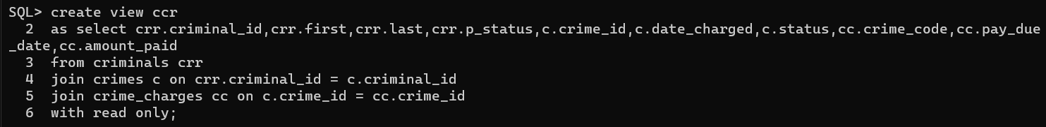 Text

   Description automatically generated
3. Text

   Description automatically generated